
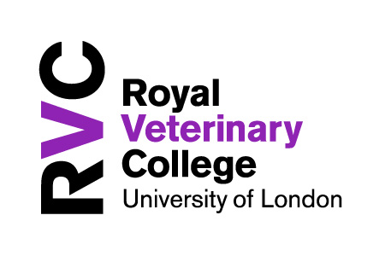
M25-LTG


CoDesignS - University of Liverpool is licensed under a CC BY-NC 4.0 - https://codesignssite.wordpress.com/

CoDesignS Learning Design Framework
BLUE CARDS

The learning activities in Blue are associated with the development of higher order cognitive skills (Bloom 1956; Kratwohl et al 1964; Toro-Troconis, 2016) aiming to design and implement learning activities that encourage dialogue, collaboration, discussion and reflection.

The cards provide examples of learning activities that can be customised to suit the learning objectives.

Discuss the learning activities suggested and explore other options along the lines of the activities provided in the these cards, keeping in mind the learners’ needs and learning context highlighted in Phase I.

________________________________________

________________________________________

________________________________________

________________________________________

________________________________________

________________________________________

________________________________________

________________________________________

________________________________________

________________________________________

________________________________________

________________________________________

________________________________________

For acquiring and discussing
Podcast & Discussion
- In this activity you ask your learners to listen to a lecture in video or Podcast format.
- After listening to the lecture, ask the students to discuss specific questions related to the topic in the forum.

- You can then ask learners to comment on their peers‘ posts.







70% 20% 10%

CoDesignS - University of Liverpool is licensed under a CC BY-NC 4.0 - https://codesignssite.wordpress.com/

ADVANCE HE: A1-A4; K1-K4

Activity
In this learning activity, the lecturer asks the students to listen to the Podcast titled: ‘Five tips for emergencies’ from the RVC Podcast library: https://bit.ly/2lWScRd and then answer some questions:
‘After listening to the Podcast presented in the previous section, reply to one or more of the following questions. Comment on 2 fellow student’s posts.
- Question 1…
- Question 2…

Learning types
This activity would drive the 70% (enquiry, practice and production), 20% (discussion) and 10% (acquisition).

________________________________________

________________________________________

________________________________________

________________________________________

________________________________________

________________________________________

________________________________________

________________________________________

________________________________________

________________________________________

________________________________________

________________________________________

________________________________________

For acquiring, enquiring & practising
Video & Critical Reflection
- In this activity you ask your learners to watch a video.
- After watching the video, ask the learners to reflect on a specific topic related to the video presented.

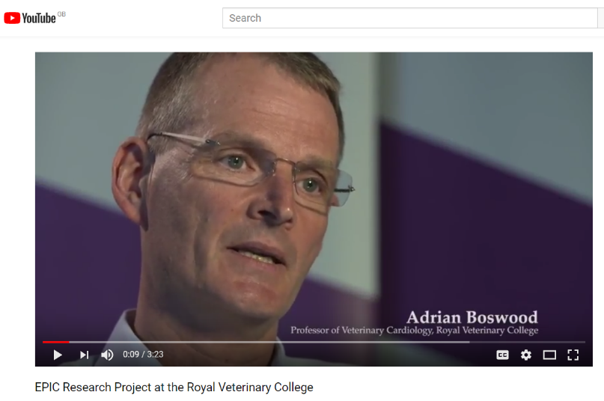

CoDesignS - University of Liverpool is licensed under a CC BY-NC 4.0 - https://codesignssite.wordpress.com/

70% 20% 10%

ADVANCE HE: A1-A4; K1-K4

Activity
In this learning activity, the lecturer asks the students to explore Professor Adrian Boswood’s view on the EPIC Research Project at the Royal Veterinary College by watching his video on YouTube: https://bit.ly/2u0diSU The lecturer then asks the students to reflect:
‘After watching Professor Boswood’s views on the efficacy of administering pimobendan to dogs with enlarged hearts (cardiomegaly) to see if it delayed the onset of heart disease, reflect on:
- The clinical importance of this development in Cardiomegaly.
- How the study design was conducted and why?
- The importance of collaboration and team work in this type of activity.’

Learning types
This activity would drive the 70% (enquiry, practice and production) and 10% (acquisition).

________________________________________

________________________________________

________________________________________

________________________________________

________________________________________

________________________________________

________________________________________

________________________________________

________________________________________

________________________________________

________________________________________

________________________________________

________________________________________



For practicing, producing and discussing
Reading & Discussion
‣ In this activity you ask your learners to read a piece of literature, news report or any other written material.
‣ After the reading activity, ask the learners to discuss in the forum specific questions related to the topic.

‣ You can then ask learners to comment on their peers‘ posts.

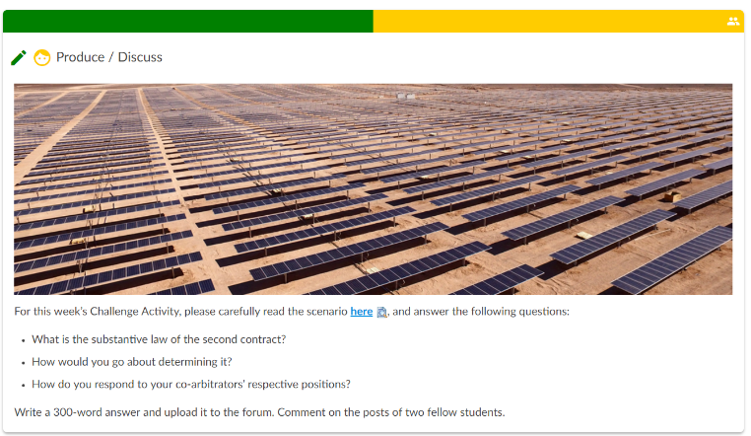

CoDesignS - University of Liverpool is licensed under a CC BY-NC 4.0 - https://codesignssite.wordpress.com/

70% 20% 10%

ADVANCE HE: A1-A4; K1-K4

Activity – Queen Mary University of London - LLM, PGDip and PGCert in International Dispute Resolution — Arbitration
In this Activity, the module lead asks the students to read the scenario given and then answer the following questions:
- What is the substantive law of the second contract?
- How would you go about determining it?
- How do you respond to your co-arbitrators’ respective positions?
Write a 300-word answer and upload it to the forum. Comment on the posts of two fellow students.

Learning types
This activity would drive the 70% (enquiry, practice and production) and 10% (acquisition).

________________________________________

________________________________________

________________________________________

________________________________________

________________________________________

________________________________________

________________________________________

________________________________________

________________________________________

________________________________________

________________________________________

________________________________________

________________________________________



For enquiring, producing, practicing and discussing
Digital Artefact & Discussion
- In this activity you ask your learners to produce a digital artefact, based on a topic you would like your learners to talk or research about. A digital artefact can be: an image, a video, a sound file, etc.
- The learners upload the digital artefact on the Forum with a description related to the task.
- You can then ask learners to comment on their peers‘ images.

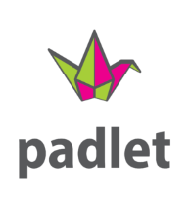
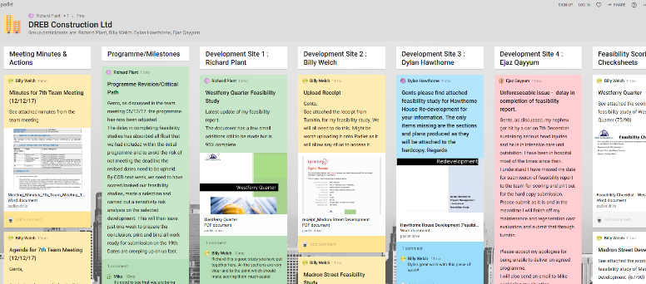
70% 20% 10%

CoDesignS - University of Liverpool is licensed under a CC BY-NC 4.0 - https://codesignssite.wordpress.com/

ADVANCE HE: A1-A4; K1-K4

Activity
Mike Hurst (Senior Lecturer at the University of East London in Civil Engineering) asks his students to work in groups to simulate a construction process.
This groupwork task is an example of an authentic task, that uses a technology such as Padlet as a tool.
Mike says:
“It not only allows other group members contributions to be seen but also, and more importantly, allows them to comment and come to a group consensus on actions that they need to collectively take.”

Learning types
This activity would mainly drive the 70% (enquiry, practice and production) and 20% (discussion).

________________________________________

________________________________________

________________________________________

________________________________________

________________________________________

________________________________________

________________________________________

________________________________________

________________________________________

________________________________________

________________________________________

________________________________________

________________________________________



For acquiring, enquiring, practicing, producing and discussing
Self-directed interactive lecture & Discussion
‣ In this activity you ask your learners to engage with a self-directed interactive lecture before a tutorial.
‣ After the learners engage with the self-directed lecture, they discuss and put into practice the concepts learned in groups in a face to face tutorial.

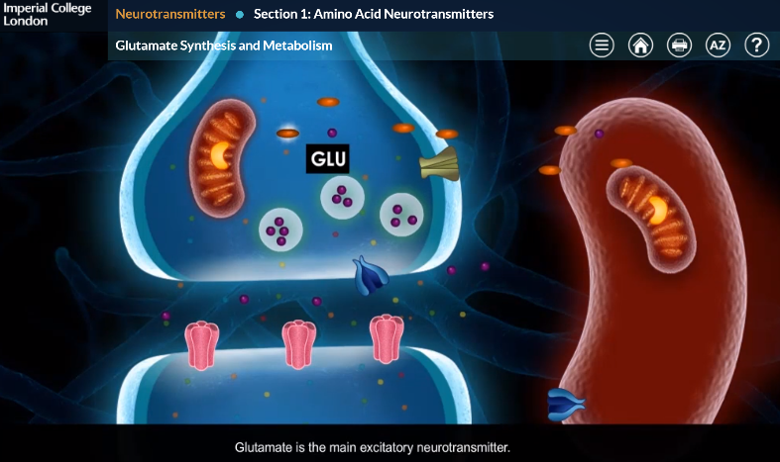

CoDesignS - University of Liverpool is licensed under a CC BY-NC 4.0 - https://codesignssite.wordpress.com/

70% 20% 10%

ADVANCE HE: A1-A4; K1-K4

Activity – BSc Module – Neuropharmacology – Imperial College London
In this activity, an existing BSc-level module delivered by Dr Sohag Saleh on neuropharmacology was redesigned using the Blended Learning Design Tool (BLEnDT).
Two online courses were developed, one on Neurotransmitters and the other on Neurodegenerative Conditions. These were supported with face-to-face tutorials. Undergraduate students’ engagement with blended learning was explored by the means of three focus groups, the data from which were analysed thematically.

Reference
Morton, C., Saleh, S., Smith, S., Hemani, A., Ameen, A., Bennie, T., Toro-Troconis (2016), ‘Blended Learning: how can we optimise undergraduate student engagement?’. BMC Medical Education Journal.; 16:195.
https://bit.ly/2RJ7KpB
Learning types
This activity would drive the 70% (enquiry, practice and production), 20% (discussion) and 10% enquiry.

________________________________________

________________________________________

________________________________________

________________________________________

________________________________________

________________________________________

________________________________________

________________________________________

________________________________________

________________________________________

________________________________________

________________________________________

________________________________________

