
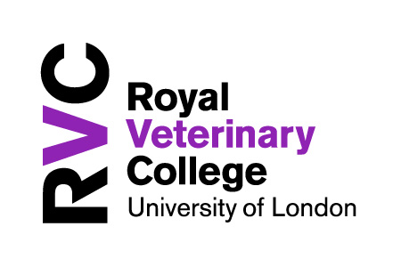
M25-LTG


CoDesignS - University of Liverpool is licensed under a CC BY-NC 4.0 - https://codesignssite.wordpress.com/

CoDesignS
Learning Design Framework
The CoDesignS Learning Design Framework is a pedagogic method for designing and developing online and blended learning activities through design, and prototyping ideas with academics, course developers and learning designers in an experiential way.
The pedagogic composition of this framework is based on the Course Design Sprint Framework (CoDesignS) developed at the University of Liverpool and the Blended Learning Design Framework (BLEnDT©) developed at Imperial College London (Toro-Troconis & Aleksiev, 2018; Toro-Troconis et al, 2016; Morton et al, 2016; Toro-Troconis, 2015).

Using the cards

Each card represents a phase. The phases have been designed to initiate discussions on key areas of the Learning Design process.

Initiate the conversation focusing on the aims and scope of your learning episode (i.e. a week of learning) and build a conversation around the indicators mentioned on each Phase.

https://codesignssite.wordpress.com/

Image by Emily Tulloh CC BY-NC 4.0
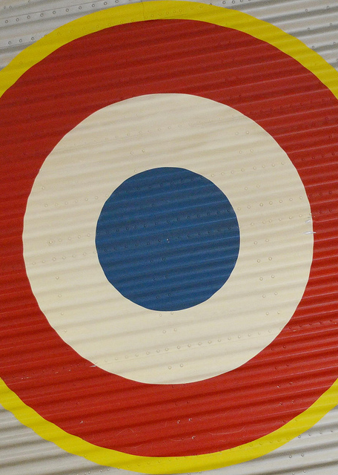

CoDesignS - University of Liverpool is licensed under a CC BY-NC 4.0 - https://codesignssite.wordpress.com/

Scope
This phase addresses user needs, technology capacity and overall scope of your learning episode.
Write down the scope of your learning intervention and discuss with other colleagues any technical and/or capability issues you may need to take into consideration.

________________________________________

________________________________________

________________________________________

________________________________________

________________________________________

________________________________________

________________________________________

________________________________________

________________________________________

________________________________________

________________________________________

________________________________________

________________________________________

Phase 1
Discuss the following questions:

- What are you planning to teach?
- Who are your learners?
- What are the digital capabilities of your learners?
- Are there any technical constraints?

Image by Tom Magliery CC BY-NC 4.0



Aims & Objectives
- Identify what you would like your learners to be able to do by selecting the verbs listed on the back of this card.
- The verbs presented in the Blue box are associated with the development of higher order cognitive skills (Bloom, 1956; Kratwohl et al, 1964; Toro-Troconis, 2015). This means implementing collaborative activities that drive conversation, and reflection. Examples of collaborative activities from different universities around London are explained in the set of Blue cards.
- The verbs presented in the Green box are associated with the development of lower order cognitive skills (Bloom, 1956; Kratwohl et al, 1964; Toro-Troconis, 2015). This means factual and procedural knowledge. For example: learning through listening, reading and watching. Examples of these activities can be found in the set of Green cards from different universities around London.
- Select the verbs that best describe what you would like your learners to be able to do by the end of your learning episode.
- Write down your learning outcomes on this card. If the verb falls within the blue box, check out the examples provided on the set of blue cards, if it falls within the green box, check out the examples provided in the green set of cards.
Explain - Discuss - Interpret - Critically appraise - Demonstrate critical awareness of - Classify - Summarise - Compare - Generate – Plan – Apply
Perform/Execute

CoDesignS - University of Liverpool is licensed under a CC BY-NC 4.0 - https://codesignssite.wordpress.com/

6.
5.
4.
Phase 2
Recognise – Identify - Retrieve - Recall
List - Define - Differentiate - Organise

________________________________________

________________________________________

________________________________________

________________________________________

________________________________________

________________________________________

________________________________________

________________________________________

________________________________________

________________________________________

________________________________________

________________________________________

________________________________________

1.
2.
3.

Image by John Flinchbaugh CC BY-NC 4.0








CoDesignS - University of Liverpool is licensed under a CC BY-NC 4.0 - https://codesignssite.wordpress.com/

Activity Descriptors

Online activity
Face to Face activity

Individual work

Group work
VLE

External tool

Activity Descriptors
This phase introduces the different technical descriptors used in the Green and Blue cards targeting the following questions:
- Would the learning activity be available fully online or blended (online/face to face)?
- Would the learning activity work for individual or group work or both?
- Can the learning activity be delivered via a Virtual Learning Environment (VLE), such as Blackboard, Canvas or Moodle?
- Does the learning activity require access to an external tool or platform, such as YouTube?
Phase 3

________________________________________

________________________________________

________________________________________

________________________________________

________________________________________

________________________________________

________________________________________

________________________________________

________________________________________

________________________________________

________________________________________

________________________________________

________________________________________

Image by Blixt CC BY-NC 4.0

Advance HE (former Higher Education Academy) - The UK Professional Standard Framework
The dimensions of the framework cover the following areas:
Areas of activity (A1, A2, A3, A4 & A5)
Core Knowledge (K1, K2, K3, K4, K5 & K6)
Professional Values (V1, V2, V3 & V4)
To find out more about the dimensions of the Professional Standard Framework visit:
http://bit.ly/1M1tkgU

CoDesignS - University of Liverpool is licensed under a CC BY-NC 4.0 - https://codesignssite.wordpress.com/

Phase 4

Learning Descriptors
This phase introduces the different descriptors used in the Green and Blue set of cards to address:
Learning types:

- Enquiry
- Acquisition
- Discussion
- Practice and
- Production (Laurillard, 2012)

The dimensions of the Advance HE (former Higher Education Academy (HEA) – UK Professional Standard Framework:

- Areas of Activity (A1-A5)
- Core Knowledge (K1-K6) and
- Professional Values (V1-V4)

HEA (2011) UK Professional Standards Framework.
HEA (2016) UKPSF: Dimensions of the Framework.
Learning Descriptors
Laurillard (2012)
Enquiry: learners use existing learning resources for their own intellectual enquiry.
Acquisition: learning through listening, reading and watching.
Discussion: learning through discussion and collaboration: with or without the tutor present, small groups or large groups, structured or unstructured.
Practice: learners apply their understanding of the concepts to achieving a task goal.
Production: learners apply their understanding of the concepts producing a tangible asset, i.e. a digital artifact.



Create, Mix & Match
- Now that you have identified the verbs from the Blue and Green sections you can start discussing how you may deliver your learning activities using the examples presented in the Blue and Green cards.
- Different icons are presented on each card to help you identify the different descriptors discussed in Phase 3 and 4.
- Use the examples presented in the Blue and Green cards as guidance for the selection of your learning activities.
- Complete the table presented at the back of this card identifying the learning types that best represent your learning activities and the time allocated for their delivery.
Learning activities | Learning Type | Time  (min)

CoDesignS - University of Liverpool is licensed under a CC BY-NC 4.0 - https://codesignssite.wordpress.com/

Phase 5

Image by Marcia O’Connor CC BY-NC 4.0


Analysis of the Learning
- It is important to review the different activities you selected for the delivery of your learning episode.
- Review the time you assigned to each of the learning types mentioned in Phase 5 (enquiry, acquisition, discussion, practice and production), in order to identify whether the learning activities offer a balanced learning approach.

CoDesignS - University of Liverpool is licensed under a CC BY-NC 4.0 - https://codesignssite.wordpress.com/

Phase 6
Type of Learning | Time | %
Acquisition
Enquiry
Discussion
Practice
Production
TOTAL

Ideally a learning activity should combine all of the learning types mentioned in Phase 4. The majority of learning comes through:

Learning through experience (Enquiry, Practice & Production) | 70%
Learning through others (Discussion) | 20%
Learning through didactic methods (Acquisition) | 10%
(Jennings, 2013; Larillard, 2012).

Review the time allocated in Phase 5 and add up all the time you estimated to spend on the different types of learning (acquisition, enquiry, discussion, practice and production). Calculate the time assigned to the different components of the 70:20:10 framework (Jennings, 2013), and review how the 70:20:10 is allocated within your week or learning episode.

The 70:20:10 split is not fixed. It is there only to guide your learning design.

Image by Tibor Micklos CC BY-NC 4.0

