


CoDesignS University of Liverpool (Toro-Troconis et al, 2016) is licensed under a CC BY-NC 4.0

Blended Learning Design Framework
BLUE CARDS

The learning activities in Blue are associated with the development of higher order cognitive skills (Bloom 1956; Kratwohl et al 1964; Toro-Troconis, 2016) aiming to design and implement learning activities that encourage dialogue, collaboration, discussion and reflection.

The cards provide examples of learning activities that can be customised to suit the learning objectives.

Discuss the learning activities suggested and explore other options along the lines of the activities provided in the these cards, keeping in mind the learners’ needs and learning context highlighted in Phase I.

________________________________________

________________________________________

________________________________________

________________________________________

________________________________________

________________________________________

________________________________________

________________________________________

________________________________________

________________________________________

________________________________________

________________________________________

________________________________________

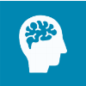






HEA: A1-A4; K1-K4 AME: 1,2,3 QAA: ---

CoDesignS University of Liverpool (Toro-Troconis et al, 2016) is licensed under a CC BY-NC 4.0
70% 20% 10%

For enquiring, producing, practicing and discussing
Digital Artefact & Discussion
- In this activity you ask your learners to produce a digital artefact, based on a topic you would like your learners to talk or research about. A digital artefact can be: an image, a video, a sound file, etc.
- The learners upload the digital artefact on the Forum with a description related to the task.
- You can then ask learners to comment on their peers‘ images.

________________________________________

________________________________________

________________________________________

________________________________________

________________________________________

________________________________________

________________________________________

________________________________________

________________________________________

________________________________________

________________________________________

________________________________________

________________________________________

Activity
The lecturer presents a clinical case in the Forum and asks the students to post an image that represents the potential differential diagnosis.
‘This may be your own photograph, or one you have found elsewhere (don’t forget to reference the source fully if you do).
Then write a few lines about why you chose this image, and how you think it illustrates the potential differential diagnosis. Comment on at least two of your peers’ images.’

Learning types
This activity would mainly drive the 70% (enquiry, practice and production) and 20% (discussion).

For acquiring and discussing
Podcast & Discussion
- In this activity you ask your learners to listen to a lecture in video or Podcast format.
- After listening to the lecture, ask the students to discuss specific questions related to the topic in the forum.

- You can then ask learners to comment on their peers‘ posts.

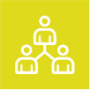
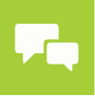



HEA: A1-A4; K1-K4 AME: 1,2,3 QAA: ---

70% 20% 10%

CoDesignS University of Liverpool (Toro-Troconis et al, 2016) is licensed under a CC BY-NC 4.0
Activity
In this learning activity, the lecturer asks the students to listen to the Podcast titled: ‘Five tips for emergencies’ from the RVC Podcast library: https://bit.ly/2lWScRd and then answer some questions:
‘After listening to the Podcast presented in the previous section, reply to one or more of the following questions. Comment on 2 fellow student’s posts.
- Question 1…
- Question 2…

Learning types
This activity would drive the 70% (enquiry, practice and production), 20% (discussion) and 10% (acquisition).

________________________________________

________________________________________

________________________________________

________________________________________

________________________________________

________________________________________

________________________________________

________________________________________

________________________________________

________________________________________

________________________________________

________________________________________

________________________________________

For acquiring, enquiring & practising
Video & Critical Reflection
- In this activity you ask your learners to watch a video.
- After watching the video, ask the learners to reflect on a specific topic related to the video presented.

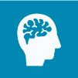
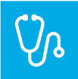
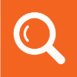
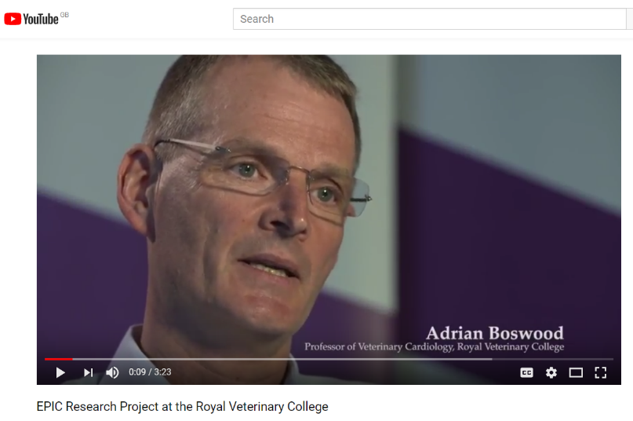

HEA: A1-A4; K1-K4 AME: 1,2,3 QAA: 3 & 5

70% 20% 10%

CoDesignS University of Liverpool (Toro-Troconis et al, 2016) is licensed under a CC BY-NC 4.0
Activity
In this learning activity, the lecturer asks the students to explore Professor Adrian Boswood’s view on the EPIC Research Project at the Royal Veterinary College by watching his video on YouTube: https://bit.ly/2u0diSU The lecturer then asks the students to reflect:
‘After watching Professor Boswood’s views on the efficacy of administering pimobendan to dogs with enlarged hearts (cardiomegaly) to see if it delayed the onset of heart disease, reflect on:
- The clinical importance of this development in Cardiomegaly.
- How the study design was conducted and why?
- The importance of collaboration and team work in this type of activity.’

Learning types
This activity would drive the 70% (enquiry, practice and production) and 10% (acquisition).

________________________________________

________________________________________

________________________________________

________________________________________

________________________________________

________________________________________

________________________________________

________________________________________

________________________________________

________________________________________

________________________________________

________________________________________

________________________________________

