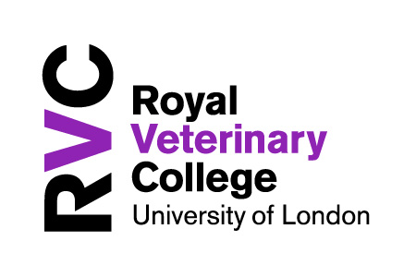



Blended Learning Design Framework
GREEN CARDS

The learning activities in Green are associated with the acquisition of knowledge and the development of lower order cognitive skills (Bloom 1956; Kratwohl et al 1964; Toro-Troconis, 2016; Toro-Troconis, 2016). This means factual and procedural knowledge. For example: learning through listening, reading and watching.

The cards provide examples of learning activities that can be customised to suit the learning objectives.

________________________________________

________________________________________

________________________________________

________________________________________

________________________________________

________________________________________

________________________________________

________________________________________

________________________________________

________________________________________

________________________________________

________________________________________

________________________________________

CoDesignS University of Liverpool (Toro-Troconis et al, 2016) is licensed under a CC BY-NC 4.0

For acquiring
Podcast or Video
- In this activity you ask your learners to listen to a lecture in video or Podcast format.
- A quiz can follow after this activity as formative assessment, providing intrinsic feedback.

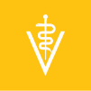






HEA: A1-A4; K1-K4 AME: 1,2,3 QAA: 1

70% 20% 10%

CoDesignS University of Liverpool (Toro-Troconis et al, 2016) is licensed under a CC BY-NC 4.0
Activity
In this learning activity, the lecturer asks the students to listen to the Podcast titled: ‘Veterinary Ethics and Animal Welfare in Clinical Practice - Part 1’ from the RVC Podcast library: https://bit.ly/2L0RWPb and then complete a Quiz available on the VLE.

Learning types
This activity would drive the 10% (acquisition).

________________________________________

________________________________________

________________________________________

________________________________________

________________________________________

________________________________________

________________________________________

________________________________________

________________________________________

________________________________________

________________________________________

________________________________________

________________________________________

For acquiring
Interactive activity
- In this activity the students engage with a self-directed, interactive learning activity receiving intrinsic feedback.
- This learning activity is encouraged in the development of procedural knowledge: activities that involve recognising steps and associations between those steps.

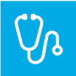


HEA: A1-A4; K1-K4 AME: 1,2,3 QAA: ---

70% 20% 10%

CoDesignS University of Liverpool (Toro-Troconis et al, 2016) is licensed under a CC BY-NC 4.0
Activity – Casting a Cow
In this interactive learning activity, the students review the steps required to execute the casting of a cow. The activity presents different Drag & Drop exercises allowing the students to practice, providing intrinsic feedback.
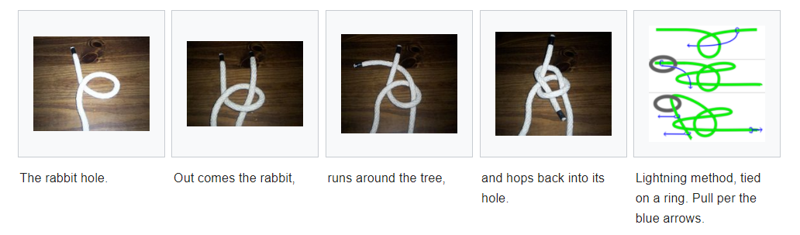

Learning types
This activity would drive the 10% (acquisition).

Image by Wikipedia CC BY 4.0

Image by Paul 3974 CC BY-NC-SA 4.0

________________________________________

________________________________________

________________________________________

________________________________________

________________________________________

________________________________________

________________________________________

________________________________________

________________________________________

________________________________________

________________________________________

________________________________________

________________________________________

For acquiring
Animation
- In this activity, an animation is presented to the learner showing a step by step process highlighting key components.

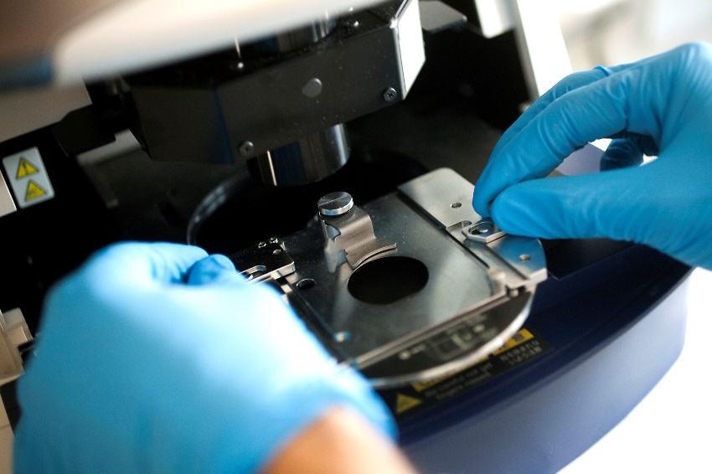
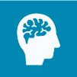

HEA: A1-A4; K1-K4 AME: 1,2,3 QAA: 2

70% 20% 10%

CoDesignS University of Liverpool (Toro-Troconis et al, 2016) is licensed under a CC BY-NC 4.0
Activity – Using a Microscope
In this animation, the students go through the steps required to operate a Microscope.
There is no intrinsic feedback embedded within this type of learning activity. A formative quiz can be used to complement this self-directed activity, reinforcing the steps and its associations

Learning types
This activity would drive the 10% (acquisition).

Image by Vall D’Hebron Institu de Reserca VHIR CC BY 4.0

________________________________________

________________________________________

________________________________________

________________________________________

________________________________________

________________________________________

________________________________________

________________________________________

________________________________________

________________________________________

________________________________________

________________________________________

________________________________________

