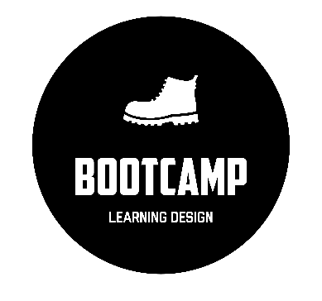
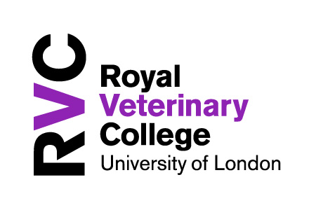



CoDesignS Learning Design Framework
GREEN CARDS

The learning activities in Green are associated with the acquisition of knowledge and the development of lower order cognitive skills (Bloom 1956; Kratwohl et al 1964; Toro-Troconis et al, 2016; Toro-Troconis, 2016). This means factual and procedural knowledge. For example: learning through listening, reading and watching.

These cards provide examples of learning activities that can be customised to suit the learning objectives.

________________________________________

________________________________________

________________________________________

________________________________________

________________________________________

________________________________________

________________________________________

________________________________________

________________________________________

________________________________________

________________________________________

________________________________________

________________________________________

CoDesignS - University of Liverpool is licensed under a CC BY-NC 4.0 - https://codesignsframework.com/



For acquiring
Animation
- In this activity the students engage with a self-directed, interactive learning activity receiving intrinsic feedback.
- This learning activity is encouraged in the development of procedural knowledge: activities that involve recognising steps and associations between those steps.

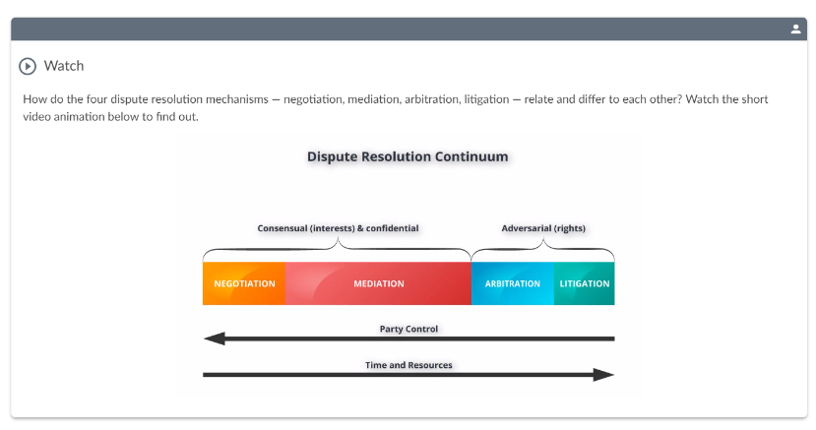




CoDesignS - University of Liverpool is licensed under a CC BY-NC 4.0 - https://codesignsframework.com/

ADVANCE HE: A1-A4; K1-K4

70% 20% 10%
Activity - Queen Mary University of London - LLM, PGDip and PGCert in International Dispute Resolution — Arbitration
In this interactive learning activity, the students learn about the four dispute resolution mechanisms — negotiation, mediation, arbitration, litigation and how they relate and differ to each other.
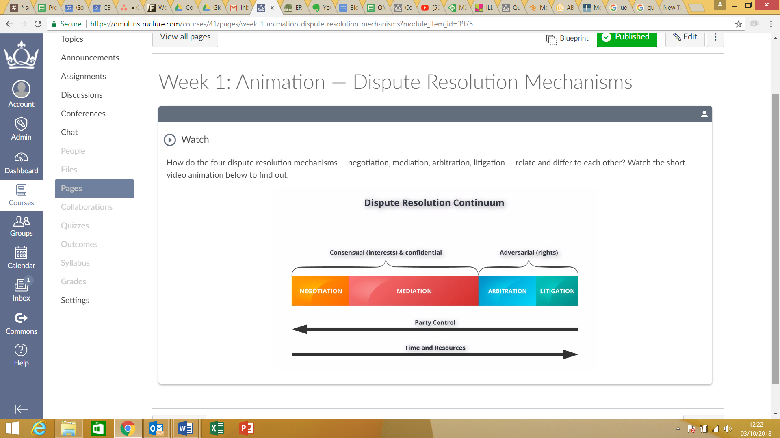

Learning types
This activity would drive the 10% (acquisition).

Image by Wikipedia CC BY 4.0

Image by Paul 3974 CC BY-NC-SA 4.0

________________________________________

________________________________________

________________________________________

________________________________________

________________________________________

________________________________________

________________________________________

________________________________________

________________________________________

________________________________________

________________________________________

________________________________________

________________________________________



For acquiring
Kahoot – Classroom Questioning
- In this activity the students engage with a set of short key terms using a classroom questionin tool such as Kahoot.
- This activity helps with retrieval practice, students test their recall of basic terms they will have read or learnt in a previous lecture, i.e. interleaving topics – so something done three weeks ago, two weeks go etc.

See a video of this here: https://youtu.be/k1GPjgJ8QmM


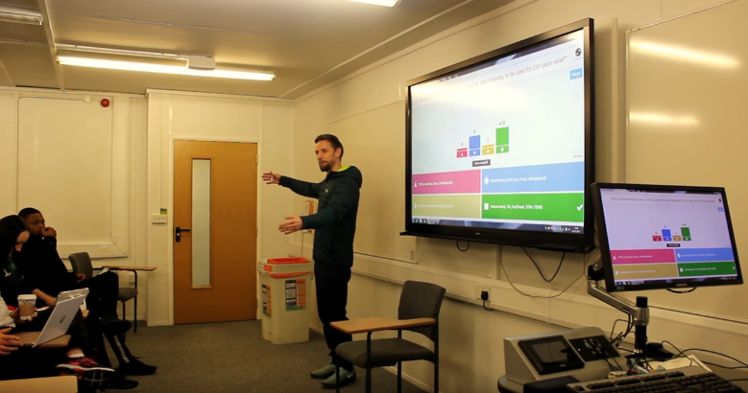


CoDesignS - University of Liverpool is licensed under a CC BY-NC 4.0 - https://codesignsframework.com/

ADVANCE HE: A1-A4; K1-K4

70% 20% 10%
Activity – Kahoot Questions in Class
In this activity, Michael Cole, Senior Lecturer in Sports Therapy at the University of East London asks his students to engage in a series of questions from topics that he will be covering or has previously covered.
This activity is typically 10 mins of a class and aids simple recall, tests pre-class reading or watching and can have a level of interleaving.
Interleaving when topics from previous weeks are tested to strengthen recall and memory.
Using the Kahoot platform, students can see where their understanding is, in relation to the rest of their peers.
The lecturer also clears up any misunderstanding of the fundamental concepts, so that more complex tasks can be tackled.

Learning types
This activity would drive the 10% (acquisition).

Image by Vall D’Hebron Institu de Reserca VHIR CC BY 4.0

________________________________________

________________________________________

________________________________________

________________________________________

________________________________________

________________________________________

________________________________________

________________________________________

________________________________________

________________________________________

________________________________________

________________________________________

________________________________________



For acquiring
Self-directed interactive iBook
- In this activity you ask your learners to engage with a self-directed interactive lecture.
- Interactive questions can be added as check points throughout the lecture as formative assessment, providing intrinsic feedback.

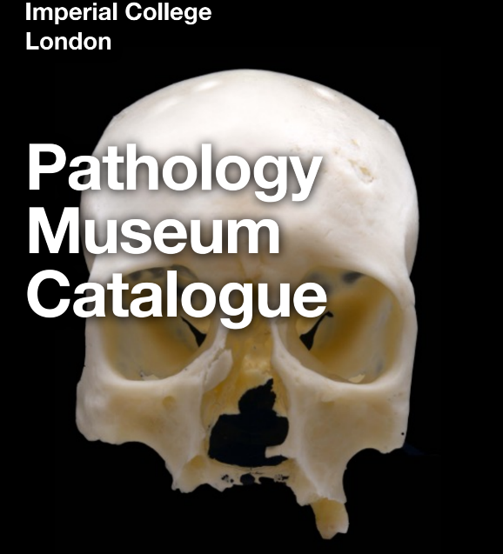



CoDesignS - University of Liverpool is licensed under a CC BY-NC 4.0 - https://codesignsframework.com/

ADVANCE HE: A1-A4; K1-K4

70% 20% 10%
Activity
In this activity medical students in clinical years engage with the Pathology Museum as part of their Pathology course.
The students have access to an iBook which contains images and 3D videos of the specimens available at the museum.
Tutors embed the use of the interactive catalogue (iBook) as part of the group activities at the museum.
The iBook also provides questions and self-test activities.

Learning types
This activity would drive the 10% (acquisition).

________________________________________

________________________________________

________________________________________

________________________________________

________________________________________

________________________________________

________________________________________

________________________________________

________________________________________

________________________________________

________________________________________

________________________________________

________________________________________



For acquiring and discussing
Video assessment brief
- In this activity you ask your learners to engage with a recording of the lecturer discussing the module’s assessment.
- Having watched the video, students prepare any questions about the brief for face-to-face discussion or to post in a module forum.

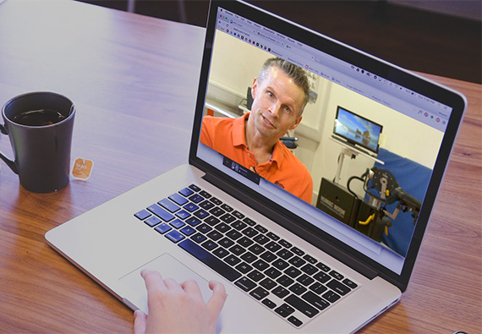


CoDesignS - University of Liverpool is licensed under a CC BY-NC 4.0 - https://codesignsframework.com/

ADVANCE HE: A1-A4; K1-K4

70% 20% 10%
Activity
This activity provides information about the assessment in multiple media: writing and video. By talking students through the brief in a video, tutors use tone of voice and emphasis to highlight key information.
The video provides stimulus material for students to prepare questions about the assessment for discussion face-to-face or in a forum. Videos can also include discussion of example assignments.
At Solent, this activity has been used successfully across the School of Sport and Health and Social Sciences. It has been proven to support students who may otherwise be at risk of failing an assessment.
Solent Tutors discuss further: tinyurl.com/rquesd4

Learning types
This activity would drive the 10% (acquisition) and potentially 20% (discussion).

________________________________________

________________________________________

________________________________________

________________________________________

________________________________________

________________________________________

________________________________________

________________________________________

________________________________________

________________________________________

________________________________________

________________________________________

________________________________________



For acquiring
Self-directed interactive H5P presentation
- In this activity learners engage with a self-directed interactive H5P presentation and they acquire new knowledge by viewing slides and a watching a series of videos.
- The activity allows learners to record free text responses to a set of predefined questions to be used later in the course for group discussion.


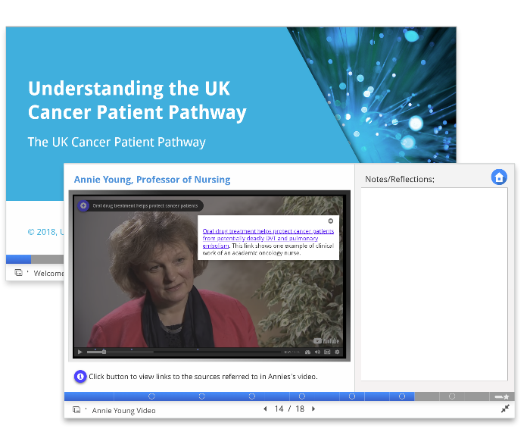

CoDesignS - University of Liverpool is licensed under a CC BY-NC 4.0 - https://codesignsframework.com/

ADVANCE HE: A1-A4; K1-K4

70% 20% 10%
Activity - UK cancer patient pathway
This activity is part of a professional development course delivered at Warwick Medical School that is designed to help leaners gain a better understanding of the UK cancer patient pathway. The activity helps learners recognise the different roles of health care professionals involved with the pathway and gain a better understanding of the patient journey and pathways of clinical care.
Slides and video personas are used to present new material, with the H5P interactive video feature allowing further information to be overlaid in the video player, making the viewing of video content a less passive experience.
Learners record their answers to a set predefined questions as they watch the videos using the H5P Exportable Text content type. This allows for responses to be exported and downloaded in Word format and used later in the course for group discussion.
Learning types
This activity would drive the 10% (acquisition).

________________________________________

________________________________________

________________________________________

________________________________________

________________________________________

________________________________________

________________________________________

________________________________________

________________________________________

________________________________________

________________________________________

________________________________________

________________________________________

